**Represention** a **binary tree**using **array**

**represent** a **binary tree**using **array** first we need to convert a binary tree into a full binary tree. and then we give the number to each node and store it into their respective locations.  
  
let's take an example to understand how to represent a binary tree using an array.  
  
to do this first we need to convert a binary tree into a full binary tree.

[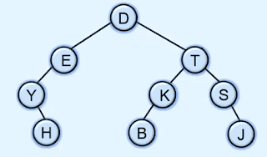](https://4.bp.blogspot.com/-Ll9mBUvZUBQ/XtM755oPpdI/AAAAAAAAM7s/9PwlNosx-Uk59SWFsWwPU5eEoAMOJoGBwCK4BGAYYCw/s1600/array-representation-of-binary-tree.png)

here in the above example to convert this binary tree into a full binary tree we need to add nodes that don't have child nodes till the last level of the tree.

[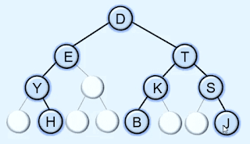](https://4.bp.blogspot.com/-LgFaHUjdW7w/XtM83LduqyI/AAAAAAAAM74/BAbs2PUplIoSHGjV7hiQOPQJfH614Pi2ACK4BGAYYCw/s1600/array-representation-of-binary-tree.png)

So now the tree becomes a full binary tree. after that to represent it using an array we need to give the numbers to each and every node but level by level.

[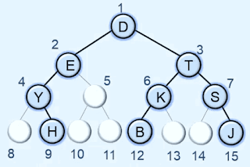](https://2.bp.blogspot.com/-1Ro93-pzJsU/XtM-Kw5xWeI/AAAAAAAAM8E/VnyRsZ9KNbUzN6QynyyeKbRzPZgqYFWTQCK4BGAYYCw/s1600/array-representation-of-binary-tree.png)

after giving the number to each and every node now we need to create an array of size 15 + 1.

[sequential Array representation of Binary tree in data structures](https://4.bp.blogspot.com/-Q2fwWSsbJCI/XtNDzGcujpI/AAAAAAAAM8Q/WNCgCRbxYcs_vL9hH9iDkuHLRQ24LAKEwCK4BGAYYCw/s1600/array-representation-of-binary-tree.png)

after that store each one node in array in their respective index points. like D has number 1 then we store it in the array at index 1 and E has number 2 then we store it at index 2 in the array.

[sequential Array representation of Binary tree in data structures](https://3.bp.blogspot.com/-R-t70FYu_Qw/XtNEnn0HekI/AAAAAAAAM8c/q1TFw3uBfIs2jDMnw1LC3FgJYfLRvuK8QCK4BGAYYCw/s1600/array-representation-of-binary-tree.png)

so this is the array representation of a binary tree.